Coursework Report – 5COSC019C Object Oriented Programming

Student Name: Dilmi Balasooriya

Student ID: w1953277 / 20220512

Have you submitted the video with the demonstration of your system? Yes No

If the video has been submitted specify where: Blackboard

On the cloud (file shared from Google drive, or OneDrive or DropBox, etc), or YouTube. **Copy here the link:** **https://drive.google.com/file/d/1QhRJFJKjPjgeL0gqR_1cc2Jr8wn5pzxN/view?usp=sharing**

# Phase 1 – Design and class implementation

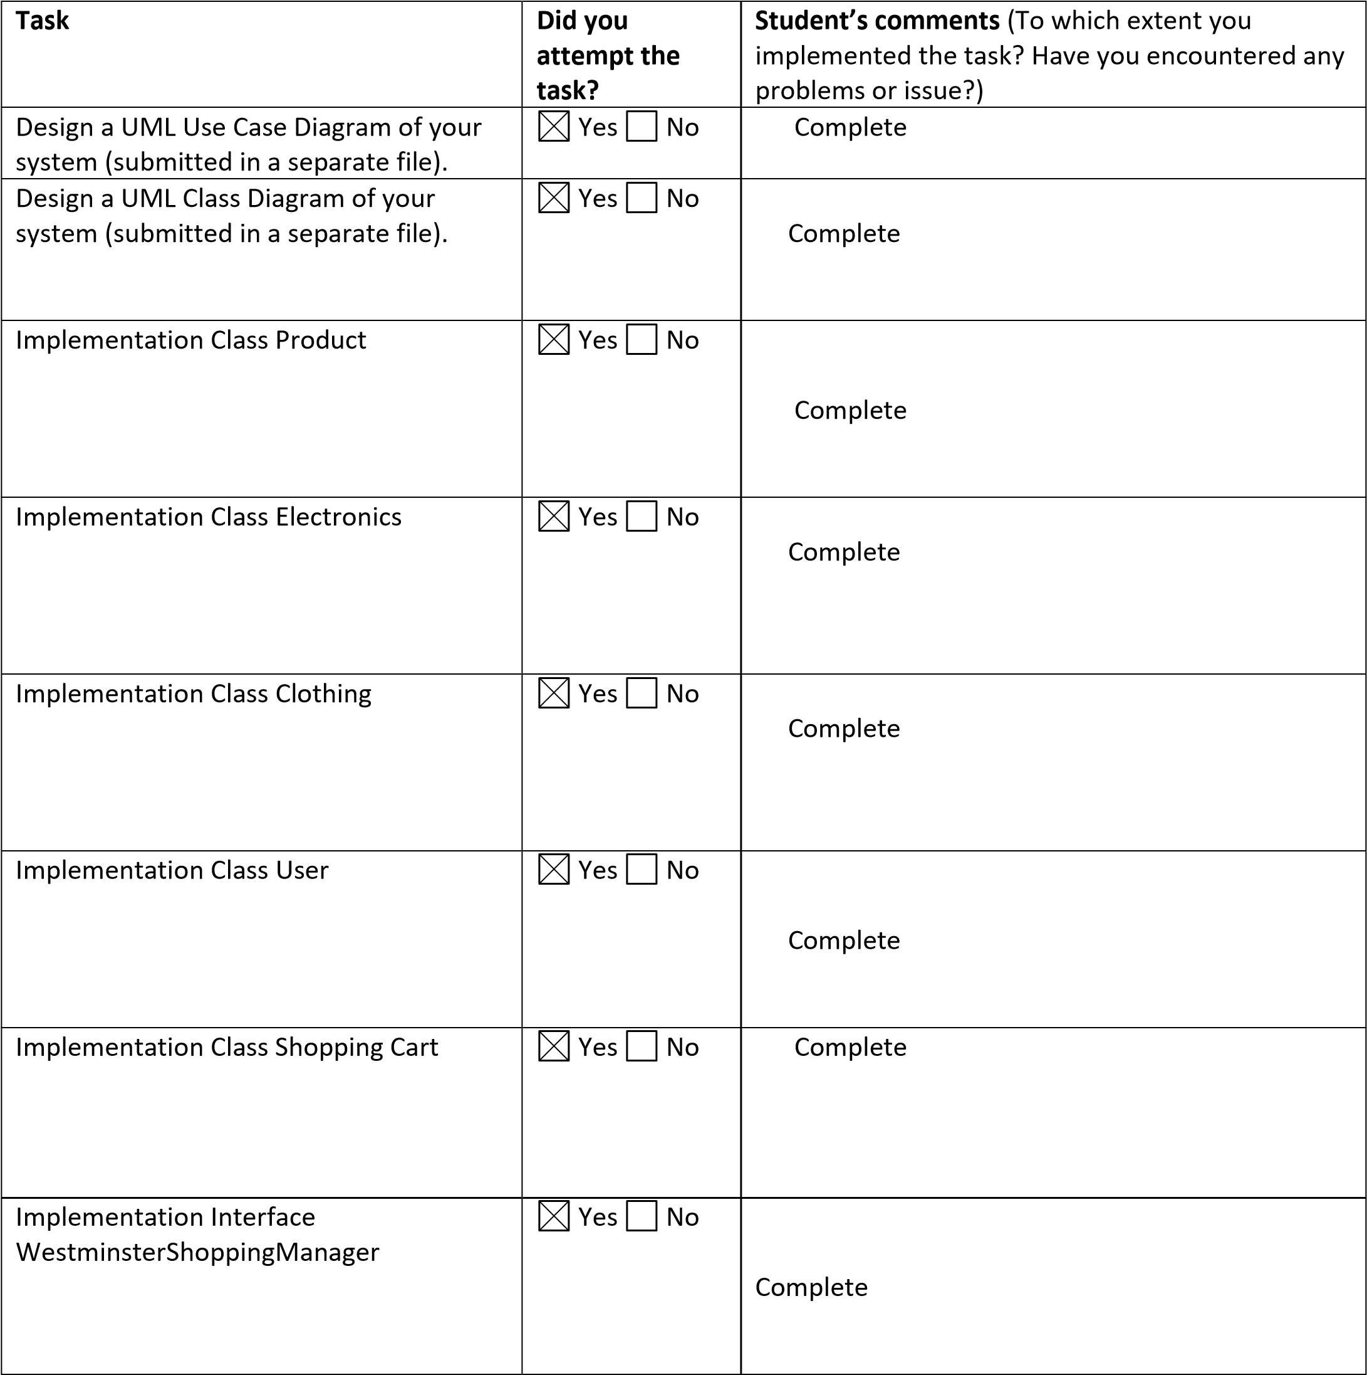

# Phase 2 – Console menu implementation

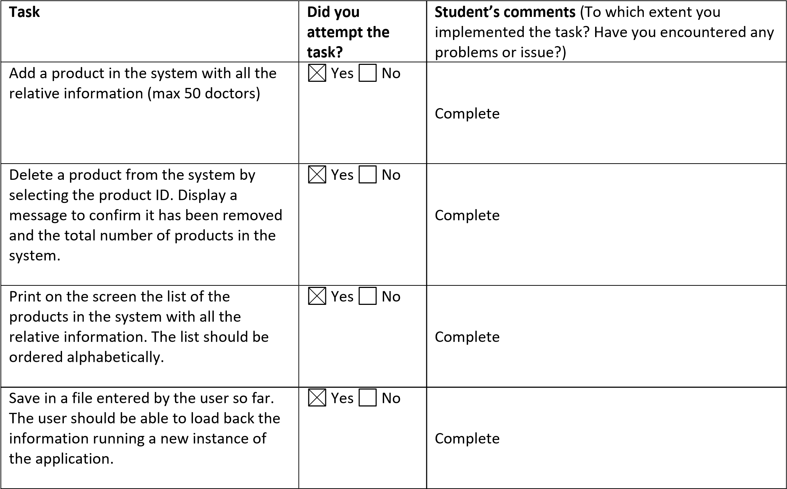

# Phase 3 – GUI Implementation

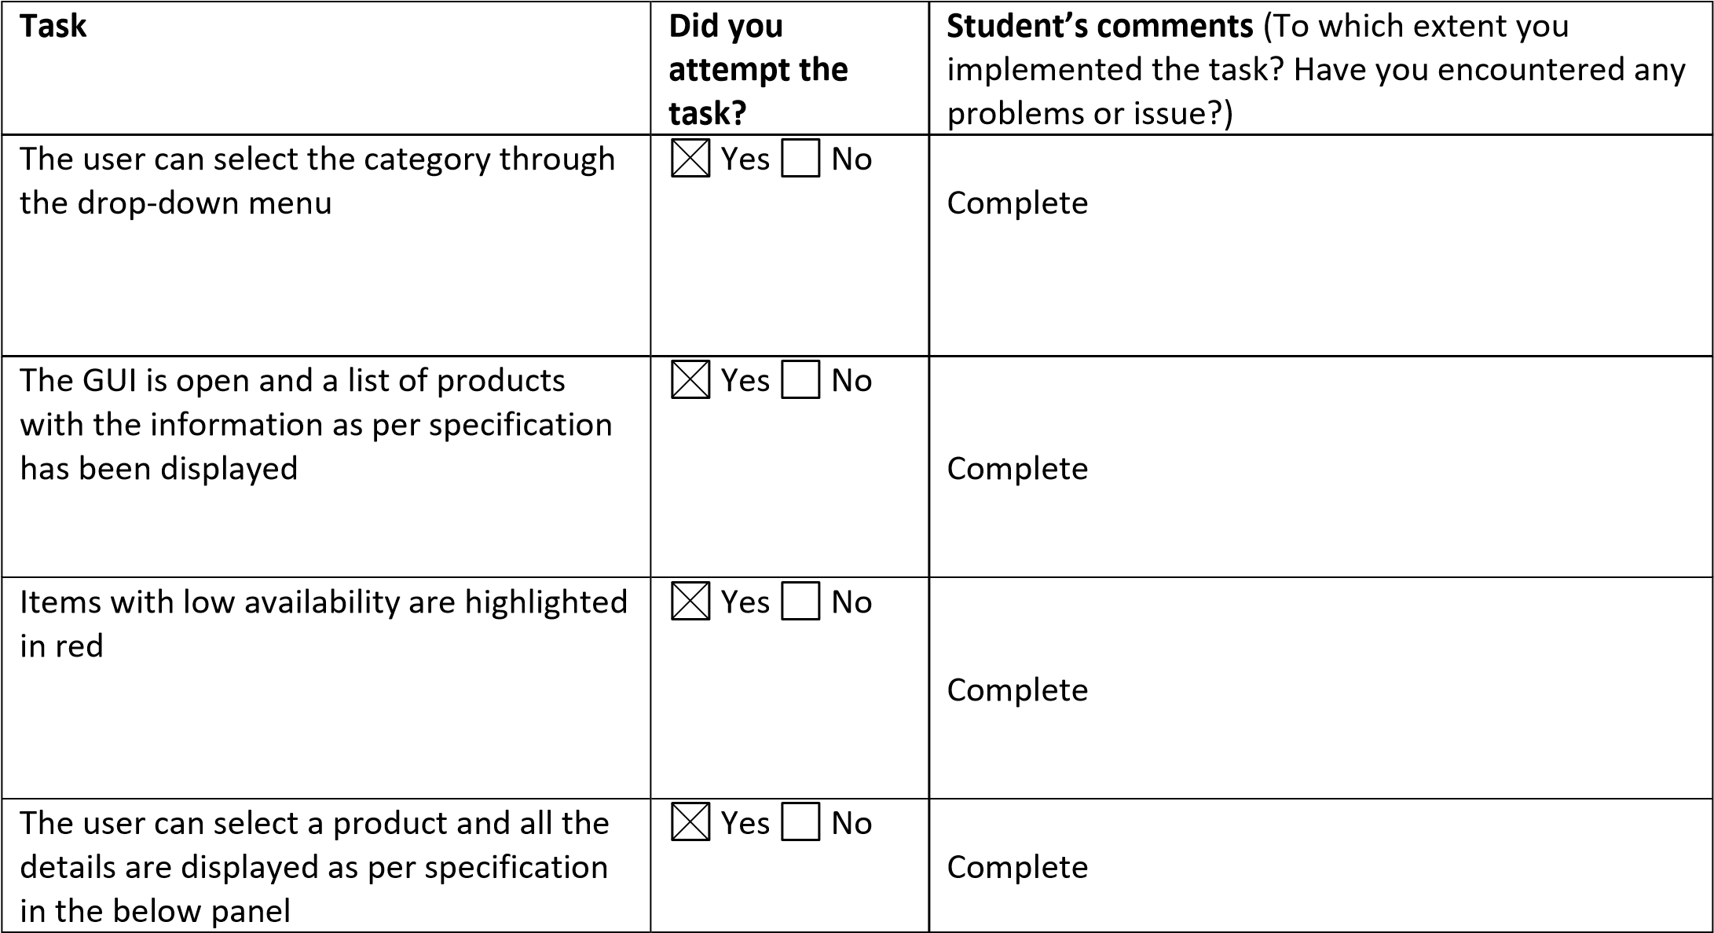

The user can add products to the

shopping cart and all the information are

displayed in a separate frame

Yes

No

Complete

The final price is displayed correctly

Yes

No

Complete

The discounts, if applicable, are displayed

as per specification and the final price

updated accordingly

Yes

No

Complete

# Phase 4 – Testing and system validation

**Task**

**Did you**

**attempt the**

**task?**

**Student’s comments**

(

To which extent you

implemented the task? Have you encountered any

problems or issue?)

Test plan.

).

Submitted in a separate file

(

Yes

No

Complete

Implementation of an automated unit

test for each scenario in the console

menu.

Yes

No

Error Handling across all the code, input

validation and code quality.

Yes

No

Complete